42.15: The volume enclosing a single sodium and chlorine atom 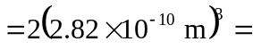
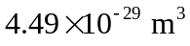. So the density
